SIGNBRIDGE INDIA
Building an ISL-Ready India
Multilingual ISL communication for everyday public-service access
Programme | YUVA Future 6.0 - Young Indians (Yi)
Track | Accessibility
Problem Statement | Indian Sign Language for All
Team Name | MITians
Institution | MITWPU
Yi Chapter / City | Pune
Team Members | Pushkar Gangurde, Shreyas Nikam, Nupur Mehta, Aryan Shinde,  Parth Agrawal

CORE PROPOSITION :
India has growing ISL resources, but communication barriers persist at public-service touchpoints. SignBridge combines multilingual ISL-to-text communication in English, Hindi, Marathi with institutional training, accessibility workflows and measurable ISL readiness.

Written Solution Report
Prepared for Chapter-Level Submission

1. PROBLEM UNDERSTANDING
Indian Sign Language (ISL) is recognised within India's disability-rights framework, and the country has made meaningful investments in ISL education and resources. Yet recognition and availability of content do not automatically translate into accessible public services. A deaf or hard-of-hearing citizen may still encounter a communication barrier at a hospital reception, bank counter, police station, school or government office because the frontline employee may not know ISL and an interpreter may not be immediately available. For the non-ISL service provider, the immediate challenge is not merely the absence of training content, but the inability to communicate effectively with an ISL user and provide the interaction in a language understood by both sides. In a multilingual country like India, this creates an additional barrier when the service provider and citizen are more comfortable using different regional languages.
The scale is significant. Government of India information based on Census 2011 reports 2.68 crore people with disabilities, of whom 19% have hearing disabilities—approximately 50.9 lakh people. The same government ecosystem is expanding ISL capacity: a December 2024 parliamentary response reported 42 institutes conducting the Diploma in Sign Language Interpretation (DISLI) and 13 conducting the Diploma in Teaching Indian Sign Language (DTISL), with 665 students undergoing DISLI/DTISL training at national institutes and Composite Regional Centres in 2024–25.
These facts point to a more precise problem than simply 'lack of ISL awareness'. India already has language resources, training pathways and educational initiatives. The gap is the last mile: converting those resources into routine, institution-level capability where citizens actually seek services.
Root-cause chain
Observed barrier | Public-service interactions remain difficult for many deaf/hard-of-hearing citizens.
Why? | Frontline service providers often lack basic, role-relevant ISL capability.
Why? | ISL learning is not consistently embedded into frontline training and service workflows.
Why? | Institutions lack both standardised ISL readiness and reliable point-of-service communication support.
Why? | Adoption is not consistently measured, incentivised or monitored across institutions.
Root cause | The missing layer is an institutional ISL adoption ecosystem—not merely a shortage of learning content.

Problem definition: India needs a practical mechanism that turns existing ISL recognition and resources into everyday, measurable communication accessibility across frontline public services, enabling ISL users and non-ISL service providers to communicate effectively.

2. PROPOSED SOLUTION
SignBridge India
SignBridge India is a multilingual ISL communication and accessibility platform that converts supported ISL gestures into coherent English, Hindi or Marathi text, while helping institutions train staff, provide communication assistance, certify readiness and measure accessibility adoption.

Solution type: Platform + Technology + Service
How it works
SignBridge India combines real-time ISL communication with institutional accessibility. An ISL user signs in front of a camera, where a computer-vision layer detects and processes the hand gesture and an initial CNN-based recognition model identifies the supported sign or character along with a confidence score. Recognised outputs are assembled into a sequence and processed by an AI language layer to generate coherent text in the user's selected output language: English, Hindi or Marathi. Around this core communication capability, SignBridge provides learning, practice, QR-based service access, institutional dashboards, certification and adoption monitoring.
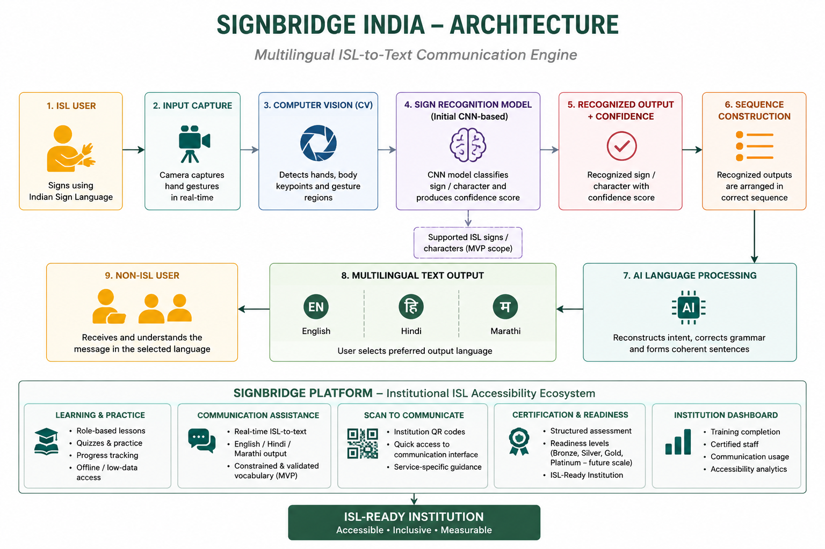

Core components
• ISL-to-Multilingual-Text Communication Engine : The core MVP communication layer that captures ISL gestures through a camera, processes them using computer vision and an initial CNN-based recognition model, constructs the recognised sequence and uses AI language processing to generate coherent English, Hindi or Marathi text. Confidence-aware recognition helps reduce ambiguous predictions.
• ISL Learing & Training Platform : Bite-sized, role-specific ISL lessons with practice, quizzes and progress tracking. The platform is designed for low-data environments and supports institutions in progressively building frontline ISL capability rather than relying only on technology-assisted communication.
• Scan to Communicate : Institution-specific QR codes provide a quick entry point to the SignBridge communication interface at reception desks, help desks and other service points, reducing the steps required for an ISL user to access communication support..
• Institutional Dashboard : A centralized dashboard tracks staff enrollment, training progress, certification, communication usage and accessibility indicators, helping institutions measure their progress toward becoming ISL-ready.
• Certifications & ISL Readiness : A structured assessment framework helps institutions measure frontline ISL capability and progressively achieve SignBridge ISL-Ready status. A more detailed tiered certification framework can be introduced during later scale-up.
• Community validation : ISL educators, Deaf-community representatives and relevant language experts validate supported signs, communication flows and user experience to improve accuracy, usability and cultural appropriateness.
Root cause → SignBridge response
Root cause | SignBridge response
Communication gap between ISL and non-ISL users | Camera-base ISL recognition → AI language processing → English/Hindi/Marathi text
No consistent frontline training | Role-based institutional learning
No common certification pathway | Standardised assessment + certification
Low point-of-service communication access | ISL-to-multilingual-text communication + QR access
Weak institutional monitoring | Readiness score + dashboard
Rural / connectivity barriers | Offline and low-data delivery
Fragmented adoption | Common ecosystem + policy standard

Target users and beneficiaries
Primary users | Institutional users | Beneficiaries
ISL users / Deaf and hard-of-hearing citizens | Hospitals, Medical colleges | ISL users seeking public services
Non-ISL frontline staff: doctors, nurses, receptionists, support staff | Government offices, Banks, Police, Schools | Families, caregivers and wider community

Important technology boundary
The MVP focuses on a defined, validated set of supported ISL signs/characters and does not claim unrestricted continuous ISL translation or full two-way communication. The initial recognition architecture can evolve toward larger vocabularies, sequence-based recognition and speech-enabled interaction. interaction.
3. POLICY RECOMMENDATION
The central policy gap is the distance between legal recognition of ISL and consistent implementation at public-service touchpoints. Government initiatives already demonstrate that ISL can be taught, documented and distributed digitally. ISLRTC is the nodal institution for advancing ISL, the ISL Dictionary contains 10,000 terms, and PM e-Vidya Channel 31 provides ISL learning content. The next step is to create a common adoption and readiness standard for institutions.
Recommended policy
We recommend that the Department of Empowerment of Persons with Disabilities (DEPwD), Ministry of Social Justice & Empowerment, in coordination with ISLRTC and relevant sector authorities, establish a phased National ISL Accessibility & Readiness Standard for essential public services, beginning with healthcare.

The standard should define minimum ISL accessibility requirements for selected public-facing institutions; introduce role-based basic ISL training for frontline staff; establish standardised, service-specific learning and assessment modules; provide at least one accessible point-of-service communication pathway; create a phased institutional readiness and certification framework; provide incentives and recognition for participating institutions; and include measurable ISL-accessibility indicators in institutional monitoring. The first phase should prioritise healthcare facilities and high-footfall government service centres, followed by schools, banks, police and other essential services.
This policy would not replace professional ISL interpreters or existing government programmes. Instead, it would create the missing institutional layer around them: a consistent way to train frontline staff, provide point-of-service communication support, assess readiness and measure adoption. Technology-assisted solutions such as SignBridge could serve as supplementary communication channels where appropriate, enabling institutions to extend accessibility across districts and states rather than relying on isolated pilots.
4. FEASIBILITY & SCALABILITY
First 90 days
Period | Priority | Deliverables
Days 1–30 | Build + validate | MVP; healthcare vocabulary; content validation; QR prototype; dashboard; pilot institutions identified.
Days 31–60 | Pilot preparation | Staff onboarding; workshops; QR deployment; user testing with Deaf/hard-of-hearing users; offline testing.
Days 61–90 | Pilot + evaluate | Launch in selected institutions; measure training, sessions and satisfaction; generate readiness scores; iterate.
Initial pilot
The team's proposed starting point is Pune: 5 hospitals and 10 schools, followed by district-level expansion. The healthcare component is a practical first use case because communication barriers can directly affect service quality, while schools provide a parallel training and awareness environment.
Indicative 90-day pilot budget
Component | Indicative allocation
ISL dataset preparation, expert validation & content | ₹2.0 lakh
CV/ML prototype + multilingual communication platform | ₹2.5 lakh
Learning, training & certification content | ₹1.5 lakh
Pilot deployment & institutional integration | ₹1.5 lakh
Community/user testing & accessibility validation | ₹1.0 lakh
Monitoring, analytics & contingency | ₹1.5 lakh
Total | ₹10 lakh
Stakeholders and roles
Stakeholder | Role
DEPwD / Government | Policy, standards, coordination and scale-up
ISLRTC / ISL experts | Language validation, curriculum and certification support
Hospitals / institutions | Pilot deployment and staff participation
Deaf community / NGOs | User validation, outreach and feedback
Colleges / CSR partners | Ambassadors, training and deployment support
SignBridge team | Technology, workflows, analytics and implementation support

The platform is designed for low-data environments, with lightweight interfaces, downloadable learning content and institution-level deployment that can operate with intermittent connectivity. Training-of-trainers models can create local champions who support staff onboarding without requiring a permanent specialist at every location. QR-based service access reduces the infrastructure required at individual service points.
Scalability roadmap
Pune pilot → Pune District → Maharashtra → Western India → National Rollout
SignBridge separates the scalable institutional layer from the evolving recognition model. New institutions, service workflows and target languages can be added progressively without requiring the entire platform to be redesigned. This allows the technology to mature alongside adoption rather than making national rollout dependent on solving unrestricted ISL recognition at the MVP stage.
3.5 INNOVATION & DIFFERENTIATION
SignBridge's innovation lies in combining multilingual ISL-to-text communication with institutional ISL readiness. Existing Indian ISL resources have made learning and reference material increasingly accessible, but the gap between learning ISL and using it during real-world service interactions remains. SignBridge connects these two layers: its communication engine converts supported ISL gestures into coherent English, Hindi or Marathi text, while its institutional layer enables training, service access, assessment and readiness monitoring..
Unique unlock: move from "ISL learning as an individual activity" to "ISL readiness as an institutional capability."

A second innovation is the separation of ISL recognition from target-language output. ISL remains the source communication language, while English, Hindi and Marathi are supported as MVP output languages. This allows the communication layer to serve India's linguistic diversity without requiring a separate ISL system for every regional language.
Existing resources can help individuals learn ISL, while professional interpreters and communication services support specific interactions. SignBridge adds a connected institutional layer that combines ISL-to-multilingual-text communication, role-based learning, QR-based service access, assessment, certification and readiness measurement. The institution, rather than only the individual learner, becomes the unit of change.
Existing resources can help individuals learn ISL, while professional interpreters and communication services support specific interactions. SignBridge adds a connected institutional layer that combines ISL-to-multilingual-text communication, role-based learning, QR-based service access, assessment, certification and readiness measurement. The institution, rather than only the individual learner, becomes the unit of change.
3.6 IMPACT POTENTIAL
The primary beneficiaries are Deaf and hard-of-hearing citizens accessing essential services, while frontline employees and institutions are the operational users. SignBridge will measure whether the intervention improves actual service accessibility, communication success and institutional readiness rather than relying on downloads or user registrations alone.
Pilot KPI | 90-day target | Why it matters
Institutions | 3-4 | Demonstrates institutional adoption
Staff enrolled | 100+ | Creates a measurable trained workforce
Staff completing basic training | 75+ | Shows learning conversion
Certified staff | 50+ | Shows assessed capability
QR access points | 10+ | Creates point-of-service access
Communication sessions | 500+ | Measures real-world use
Communication success rate | ≥80% target | Measures whether users can complete intended routine interactions

All figures above are proposed 90-day pilot targets, not achieved results. Baseline measurements will be established during the initial deployment, and targets will be refined using observed usage, communication success and user feedback.
CONCLUSION
India has moved beyond the stage of asking whether ISL should be recognised. The next challenge is making accessible communication routine where citizens use essential services. SignBridge India proposes a practical bridge between policy and implementation: multilingual ISL communication → training → service access → institutional readiness → measurement → national adoption. Its MVP enables supported ISL gestures to be converted into coherent English, Hindi or Marathi text, while the wider platform helps institutions build the capability to become progressively ISL-ready.
We are not building another technology that asks citizens to adapt to inaccessible systems. We are building an ecosystem that helps those systems adapt to them.

REFERENCES
[1] Government of India, Ministry of Social Justice & Empowerment / PIB, "Parliament Question: Indian Sign Language," 11 March 2025. https://www.pib.gov.in/PressReleasePage.aspx?PRID=2110150
[2] Government of India, Ministry of Social Justice & Empowerment / PIB, "Provision for Sign Language for the Deaf across the Country," 4 December 2024. https://www.pib.gov.in/PressReleasePage.aspx?PRID=2080565
[3] ISLRTC, Government of India, FAQ / Indian Sign Language Dictionary: 10,000 terms. https://islrtc.nic.in/faq/
[4] Government of India, Ministry of Education / PIB, "PM e-Vidya DTH Channel for Indian Sign Language," 6 December 2024. https://www.pib.gov.in/PressReleasePage.aspx?PRID=2081633
[5] Young Indians (Yi), YUVA Future 6.0, "Solution Submission Format," supplied competition SOP PDF.

